<https://github.com/pusher/pusher-js>

Instalar via composer:

<https://github.com/pusher/pusher-http-php>

rafael.franco@NOTWEB-O1 MINGW64 /e/PROGRAMAS/www/code-md-angular-laravel-front (master)

$ composer require pusher/pusher-php-server:~2.0

./composer.json has been updated

> php artisan clear-compiled

Loading composer repositories with package information

Updating dependencies (including require-dev)

- Installing pusher/pusher-php-server (v2.3.0)

Downloading: 100%

Writing lock file

Generating autoload files

> php artisan optimize

Generating optimized class loader

rafael.franco@NOTWEB-O1 MINGW64 /e/PROGRAMAS/www/code-md-angular-laravel-front (master)

$

Instalar via bower:

<https://github.com/pusher/pusher-js>

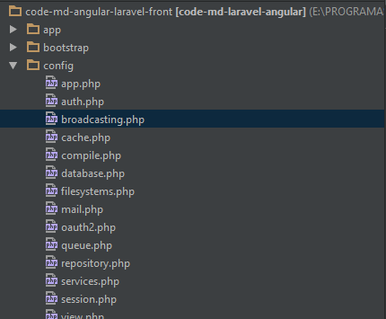

rafael.franco@NOTWEB-O1 MINGW64 /e/PROGRAMAS/www/code-md-angular-laravel-front (master)

$ bower install pusher --save

bower angular-strap#^2.3.8 cached https://github.com/mgcrea/angular-strap.git#2.3.8

bower angular-strap#^2.3.8 validate 2.3.8 against https://github.com/mgcrea/angular-strap.git#^2.3.8

bower pusher#* not-cached https://github.com/pusher/pusher-js.git#*

bower pusher#* resolve https://github.com/pusher/pusher-js.git#*

bower pusher#* checkout v3.0.0

bower pusher#* resolved https://github.com/pusher/pusher-js.git#3.0.0

bower angular-strap#^2.3.8 install angular-strap#2.3.8

bower pusher#^3.0.0 install pusher#3.0.0

angular-strap#2.3.8 resources\bower_components\angular-strap

└── angular#1.4.1

pusher#3.0.0 resources\bower_components\pusher